## Watch Alarm Panel 1st, 2nd and 3rd stage

### Specification

The two different panels are shown in the following figures:

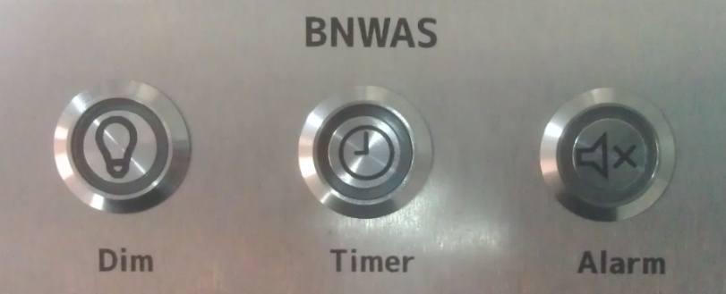

Figure 2‑39: BNWAS WAP large

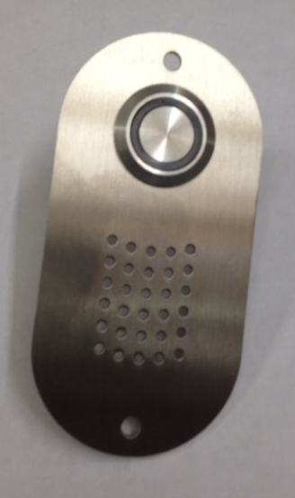

Figure 2‑40: BNWAS WAP small

These panels can be used on the bridge, but also on the locations where the 2nd and 3rd stage alarms need to be shown.

### Installation

|  |  |
| --- | --- |
| Panel horizontal-vertical | |
|  | |
|  | |
| Location of use: | Main Bridge |

Figure 2‑41: BNWAS panel large

|  |  |  |  |
| --- | --- | --- | --- |
| Button | Color | Function | NavVision Field (Button/Led) |
| Dim | Blue | Dim panel lights* | Station Bridge Deadman Panel Dim Switch |
| Station Bridge Deadman Panel Dim LED |
| Timer | Green | Reset timer  Illuminates when active | Station Bridge Timer Reset |
| Station Bridge Timer Active LED |
| Alarm | Red | Alarm silence** | Station Bridge Deadman Silence |
| Station Bridge Deadman Alarm Active LED |
| Buzzer |  | Alarm*** | Station Bridge Deadman Alarm Buzzer |

Figure 2‑42: BNWAS panel large field assignment

|  |  |
| --- | --- |
| Panel horizontal-vertical | |
|  | |
|  | |
| Location of use: | All spaces where Bridge duty crew can be available (no duty select) |

Figure 2‑43: BNWAS panel small

|  |  |  |  |
| --- | --- | --- | --- |
| Button | Color | Function | NavVision© Field (Button/Led) |
| BNWAS | Red | Bridge duty and timer reset | Station Bridge Deadman Silence |
| Station Bridge Deadman Alarm Active LED |
| Buzzer |  | Alarm*** | Station Bridge Deadman Alarm Buzzer |

Figure 2‑44: BNWAS panel small field assignment

The panels come pre-wired. The cables can be directly connected to the wago, or through a terminal (if the distance is longer). The wiring lies outside the scope of the type approval.

The panels can be mounted on practically every surface. It is a non-flush mounting. The panels are tightened by 4 screws or bolts.